

PENNYSTACK: SMART PERSONAL EXPENSE TRACKER
Using Data Structures.

Data Structures Project Report

Submitted By:
Abdul Rafay (Roll No: 243705)

Course & Instructor:
Subject Instructor: Mr. Syed Atta ur Rehman
Subject: Data Structures

Institution Details:
Air University, Multan Campus
Spring 2025

Table of Contents
Data Structures Project Report 1
1. EXECUTIVE SUMMARY 4
2. INTRODUCTION 4
2.1 Background 4
2.2 Motivation 4
2.3 Scope 4
3. PROBLEM STATEMENT 5
4. OBJECTIVES 5
4.1 Primary Objectives 5
4.2 Secondary Objectives 6
5. SYSTEM REQUIREMENTS 6
5.1 Software Requirements 6
5.2 Development Tools 6
6. DATA STRUCTURES IMPLEMENTATION 6
6.1 Doubly Linked List: 6
6.2 Stack: 8
6.3 Queue: 9
6.4 Binary Search Tree (BST) 10
6.5 Hashing 11
7. SYSTEM FEATURES 12
7.1 User Authentication 12
7.2 Transaction Management 12
7.3 Undo Functionality 13
7.4 Transaction History 13
7.5 Bill Scheduling 13
7.6 Bill Payment 14
7.7 Category Report 14
7.8 Data Persistence 15
8. SYSTEM ARCHITECTURE 16
8.1 System Flow Diagram 16
8.2 Class Diagram 17
8.3 Data Flow Diagram 18
COMPLETE SYSTEM FLOW: 20
9. IMPLEMENTATION DETAILS 21
9.1 Key Functions: 21
9.2 Memory Management 22
9.3 File Handling 22
10. TESTING & RESULTS 23
10.1 Test Cases 23
10.2 Performance Analysis 26
10.3 Test Summary 26
11. SCREENSHOTS 27
11.1 User Interface Screenshots 27
12. CONCLUSION 31
12.1 Project Summary 31
12.2 Objectives Achievement 31
12.3 Learning Outcomes 32
12.4 Project Impact 33
12.5 System Strengths 33
12.6 Limitations 34
12.7 Final Remarks 34

1. EXECUTIVE SUMMARY
PennyStack is a comprehensive personal expense tracking application developed using C++ that implements multiple data structures to provide efficient financial management. The system allows users to track income and expenses, manage bills, categorize spending, and maintain complete transaction history with undo functionality. The application demonstrates practical implementation of Doubly Linked Lists, Stacks, Queues, Binary Search Trees, and Hashing algorithms.

2. INTRODUCTION

2.1 Background
In today's fast-paced world, managing personal finances has become increasingly important. Many individuals struggle to keep track of their daily expenses, leading to poor financial decisions and budget overruns. PennyStack addresses this challenge by providing an intuitive, efficient, and secure platform for personal expense management.

2.2 Motivation
The motivation behind developing PennyStack stems from:
- Need for efficient personal finance management
- Practical application of data structures concepts
- Providing a user-friendly solution for expense tracking
- Demonstrating real-world problem-solving using programming

2.3 Scope
This project covers:
- Transaction management (Income/Expense)
- Bill scheduling and payment
- Category-wise expense analysis
- Undo functionality for error correction
- Secure PIN-based authentication
- Persistent data storage

3. PROBLEM STATEMENT
Many individuals face difficulties in:
- Tracking daily income and expenses
- Managing upcoming bills and payments
- Analyzing spending patterns by category
- Correcting mistaken entries
- Maintaining secure financial records
- Accessing historical transaction data
Solution: PennyStack provides a comprehensive solution by implementing efficient data structures that enable fast operations, organized data management, and secure access control.

4. OBJECTIVES

4.1 Primary Objectives
- Develop a functional expense tracking system
- Implement multiple data structures effectively
- Provide secure user authentication
- Enable efficient data retrieval and manipulation
- Maintain persistent data storage

4.2 Secondary Objectives
- Create an intuitive user interface
- Implement error handling and validation
- Provide visual spending analysis
- Enable transaction history management
- Support bill scheduling and payment

5. SYSTEM REQUIREMENTS

5.1 Software Requirements
- Operating System: Windows 7/8/10/11
- Compiler: GCC/MinGW or Visual C++
- IDE: Code::Blocks, Dev-C++, or Visual Studio
- C++ Standard: C++11 or higher

5.2 Development Tools
- Text Editor/IDE
- C++ Compiler
- File System Access
- Console/Terminal

6. DATA STRUCTURES IMPLEMENTATION

6.1 Doubly Linked List:
Purpose: Store transaction history with bidirectional traversal

Structure:
struct Transaction {
int id;
double amount.
string type.
string category.
Transaction* next.
Transaction* Prev;
};
Operations:
- Insert at front: O(1)
- Delete node: O(1)
- Traverse: O(n)
Advantages:
- Efficient insertion/deletion
- Bidirectional traversal
- Easy undo implementation
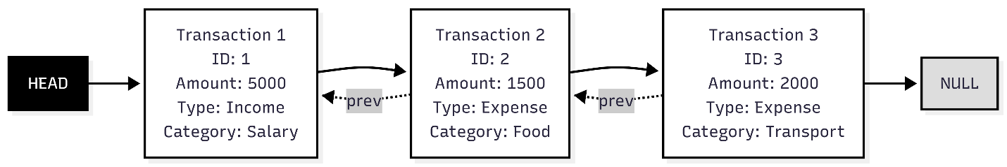

6.2 Stack:
Purpose: Implement undo functionality for last transaction
Structure:
struct StackNode{
Transaction* trans;
StackNode* next;
};
Operations:
- Push: O(1)
- Pop: O(1)
- Peek: O(1)
Advantages:
- LIFO behavior perfect for undo
- Constant time operations
- Simple implementation
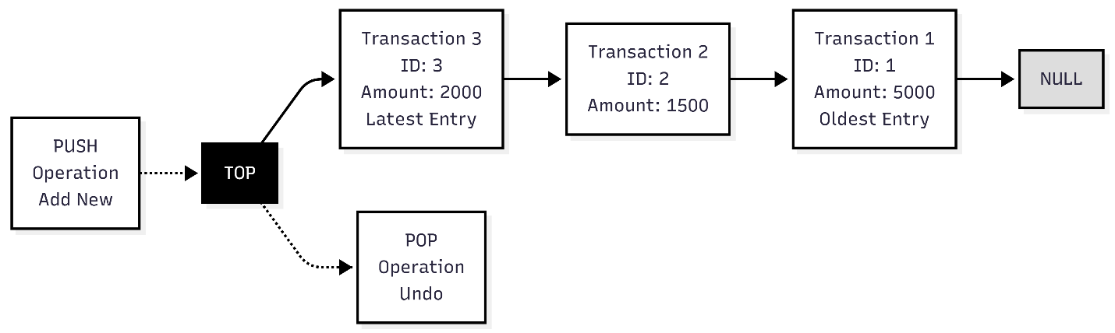

6.3 Queue:
Purpose: Schedule and manage pending bills (FIFO)
Structure:
struct BillNode{
string billName;
double billAmount;
BillNode* next;
};
Operations:
- Enqueue: O(1)
- Dequeue: O(1)
Advantages:
- Fair bill processing (first scheduled, first paid)
- Efficient queue operations
- Simple bill management
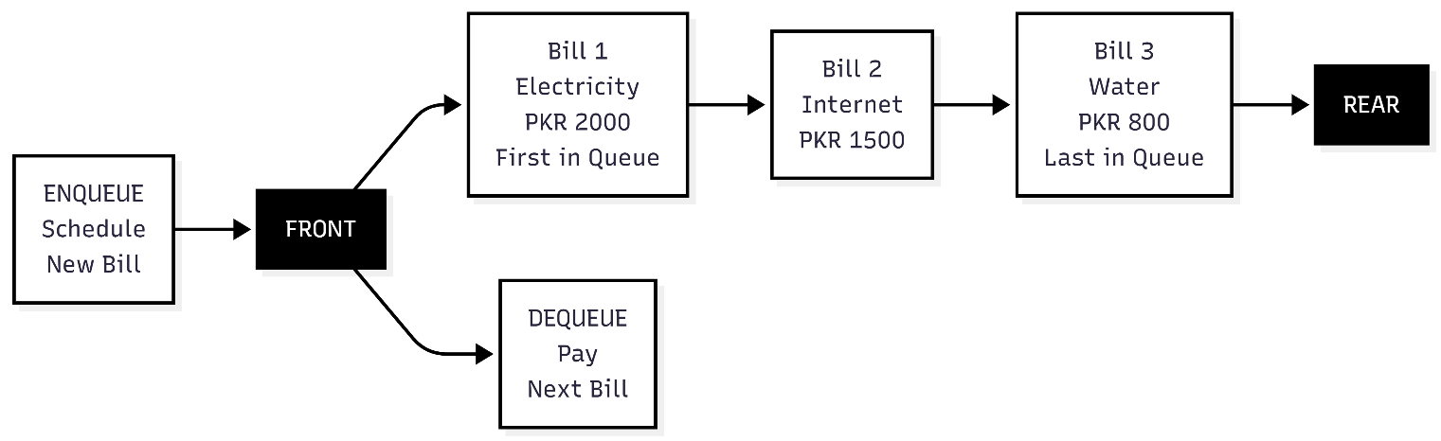

6.4 Binary Search Tree (BST)
Purpose: Organize and search expenses by category
Structure:
struct CategoryNode{
string categoryName;
double totalSpent;
CategoryNode* left;
CategoryNode* right;
};
Operations:
- Insert: O(log n) average
- Search: O(log n) average
- Delete: O(log n) average
- In-order traversal: O(n)

Advantages:
- Fast category search
- Sorted category display
- Efficient updates
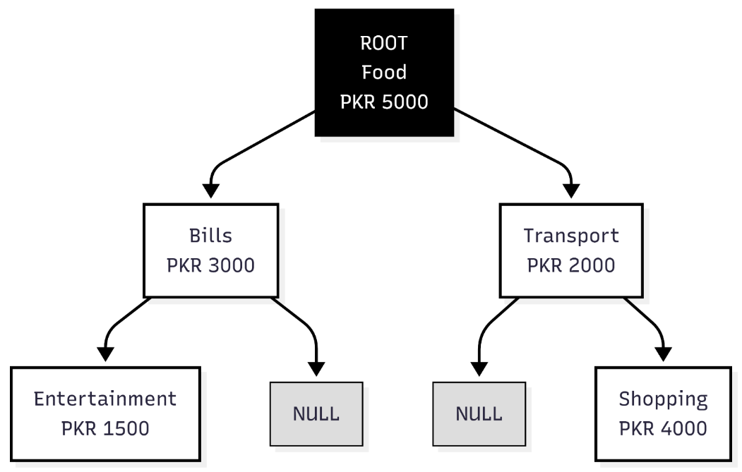

6.5 Hashing
Purpose: Secure PIN authentication
Implementation:
int hashPIN(int pin){
return (pin % 1000) * 5 + 7;
}
Advantages:
- One-way encryption
- Fast verification
- Secure storage
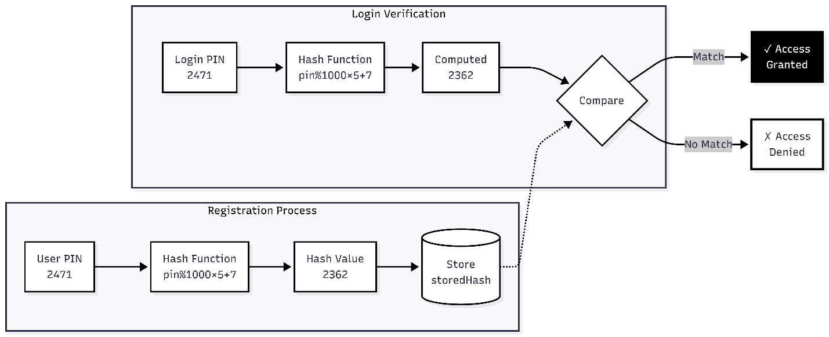

7. SYSTEM FEATURES

7.1 User Authentication
- Secure PIN-based login
- Hash-based password storage
- Access control mechanism
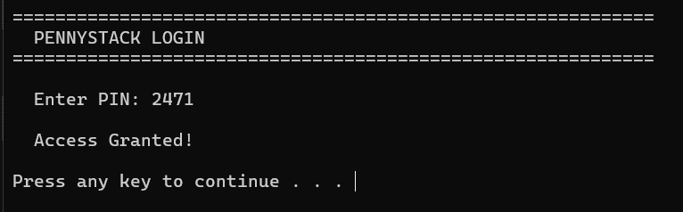

7.2 Transaction Management
- Add income/expense transactions
- Automatic balance calculation
- Category assignment
- Unique transaction ID generation
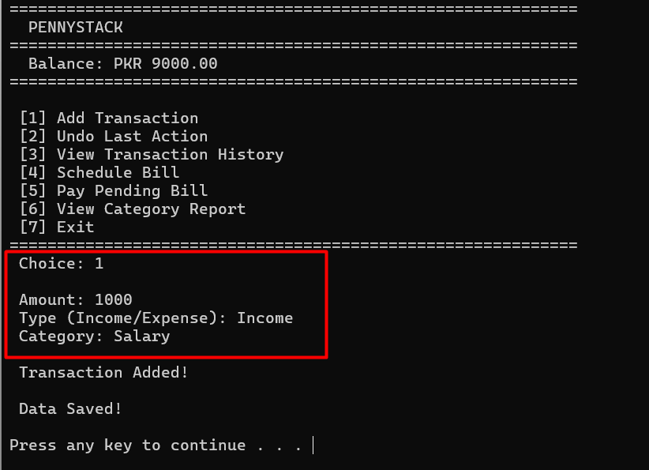

7.3 Undo Functionality
- Reverse last transaction
- Automatic balance adjustment
- BST category update
- Stack-based implementation
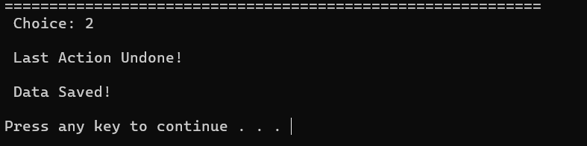

7.4 Transaction History
- View all transactions
- Display ID, type, category, amount
- Transaction count
- Chronological order
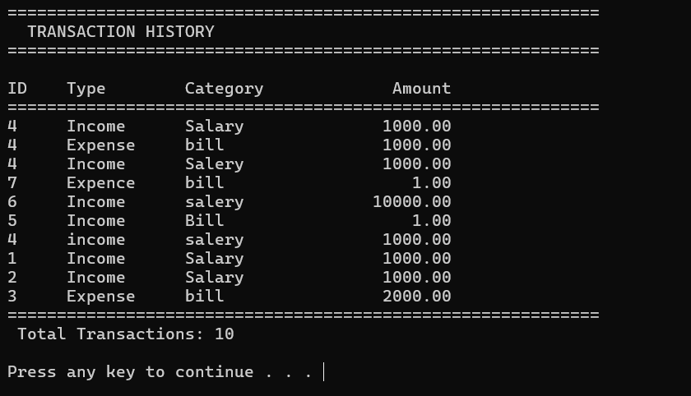

7.5 Bill Scheduling
- Schedule upcoming bills
- Queue-based management
- Bill name and amount storage
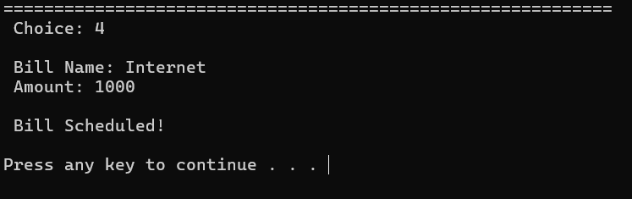

7.6 Bill Payment
- Pay next pending bill
- Balance verification
- Automatic transaction creation
- Queue dequeue operation
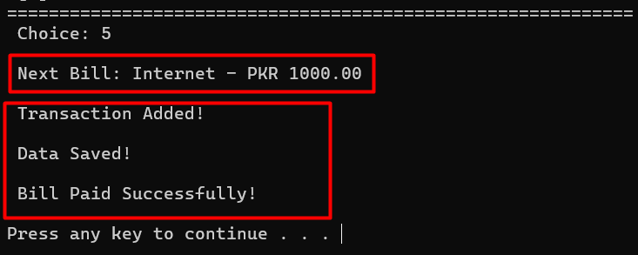

7.7 Category Report
- Search expenses by category
- Display total spending
- Visual bar chart representation
- BST-based search
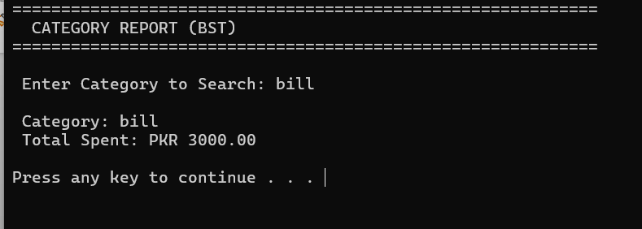

7.8 Data Persistence
- Save data to file
- Load data on startup
- Maintain balance across sessions
- Transaction history preservation
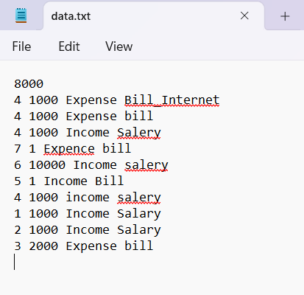

8. SYSTEM ARCHITECTURE

8.1 System Flow Diagram
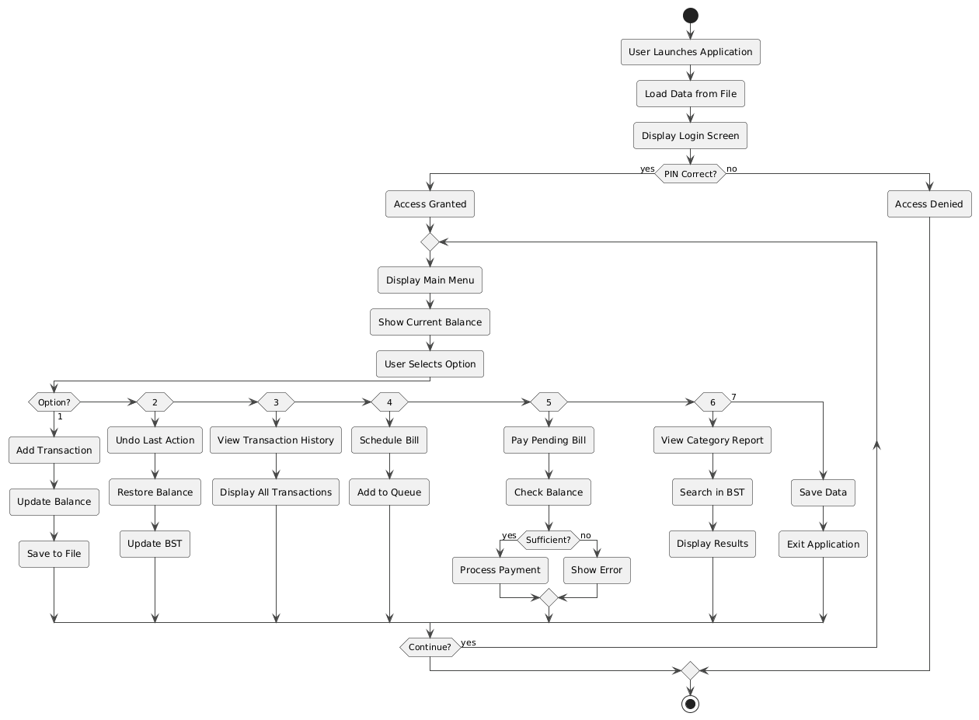

8.2 Class Diagram
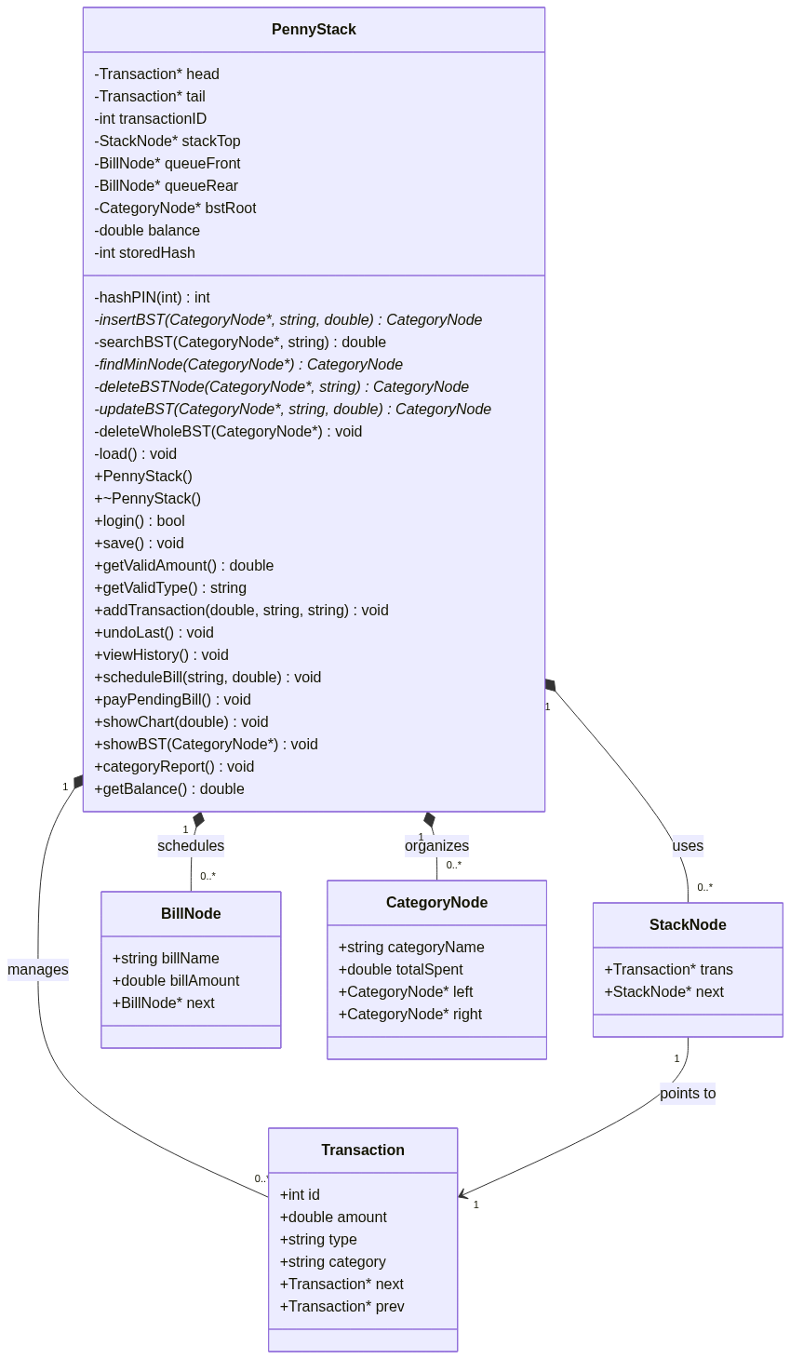

8.3 Data Flow Diagram

Level 0 (Context Diagram):
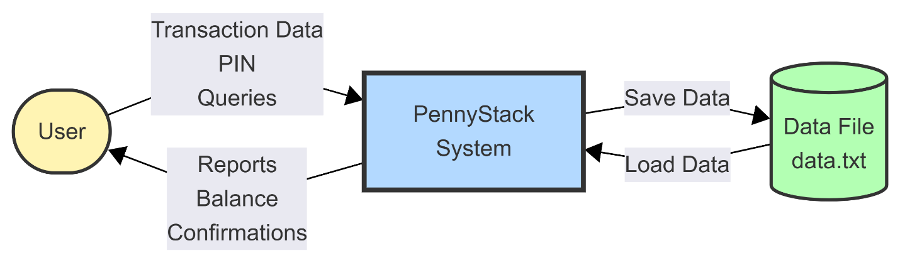

Level 1: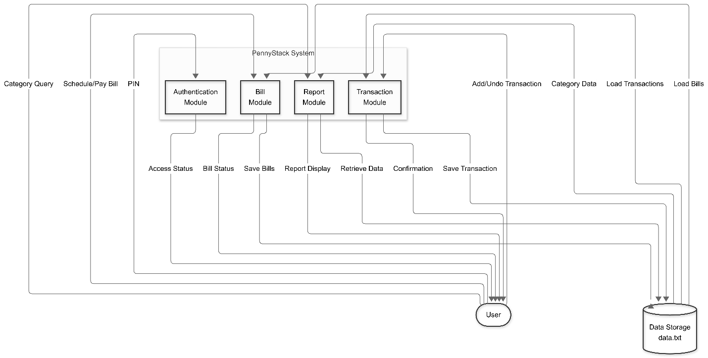

Level 2: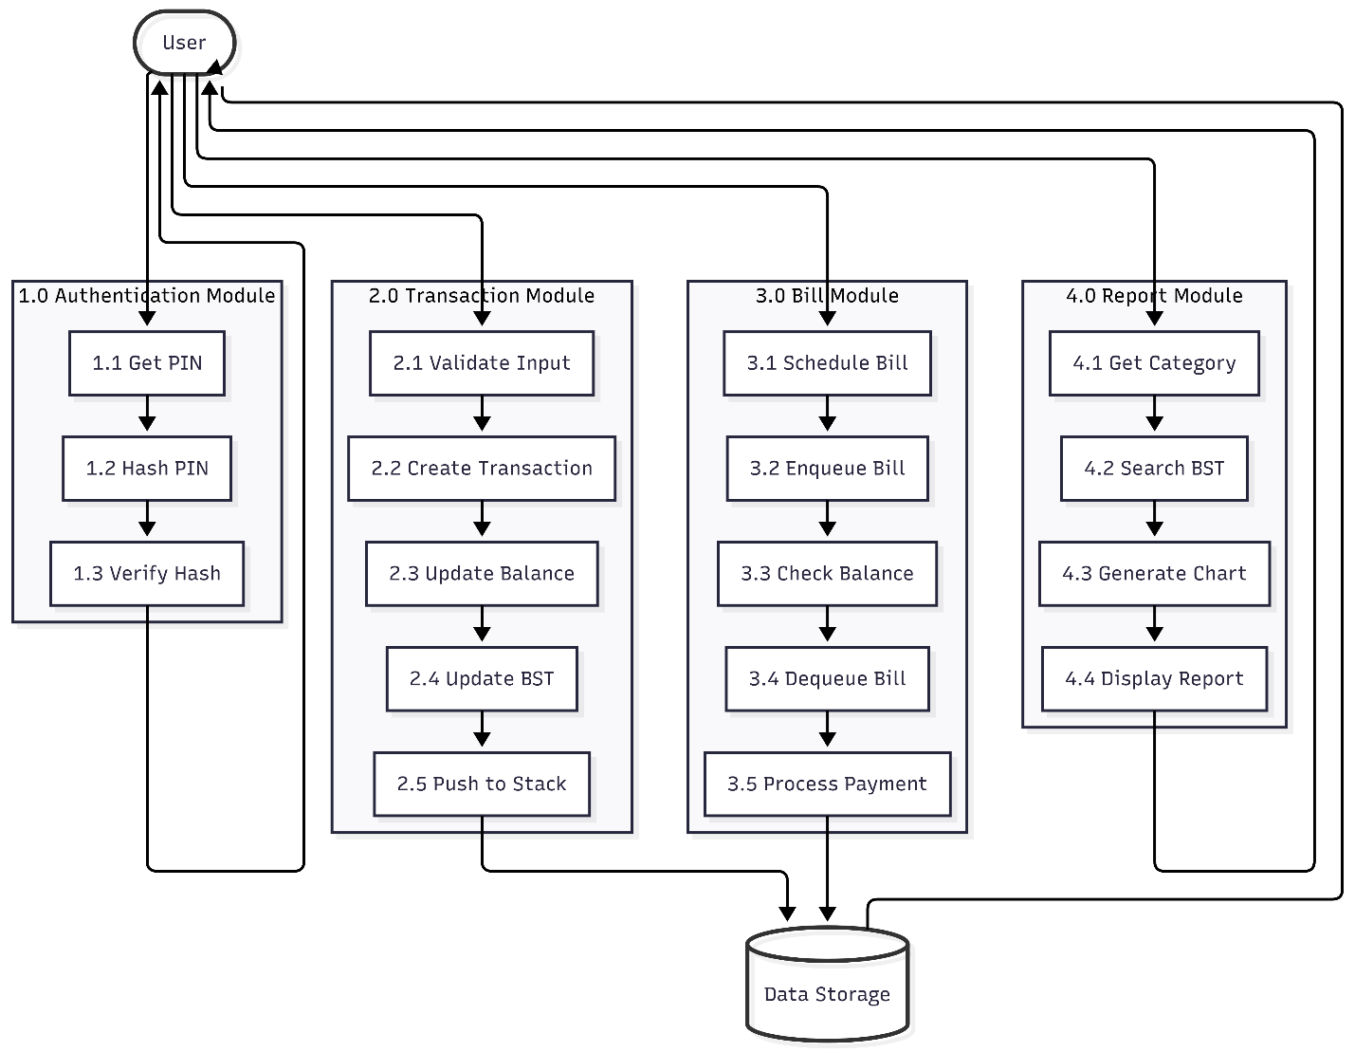

COMPLETE SYSTEM FLOW:

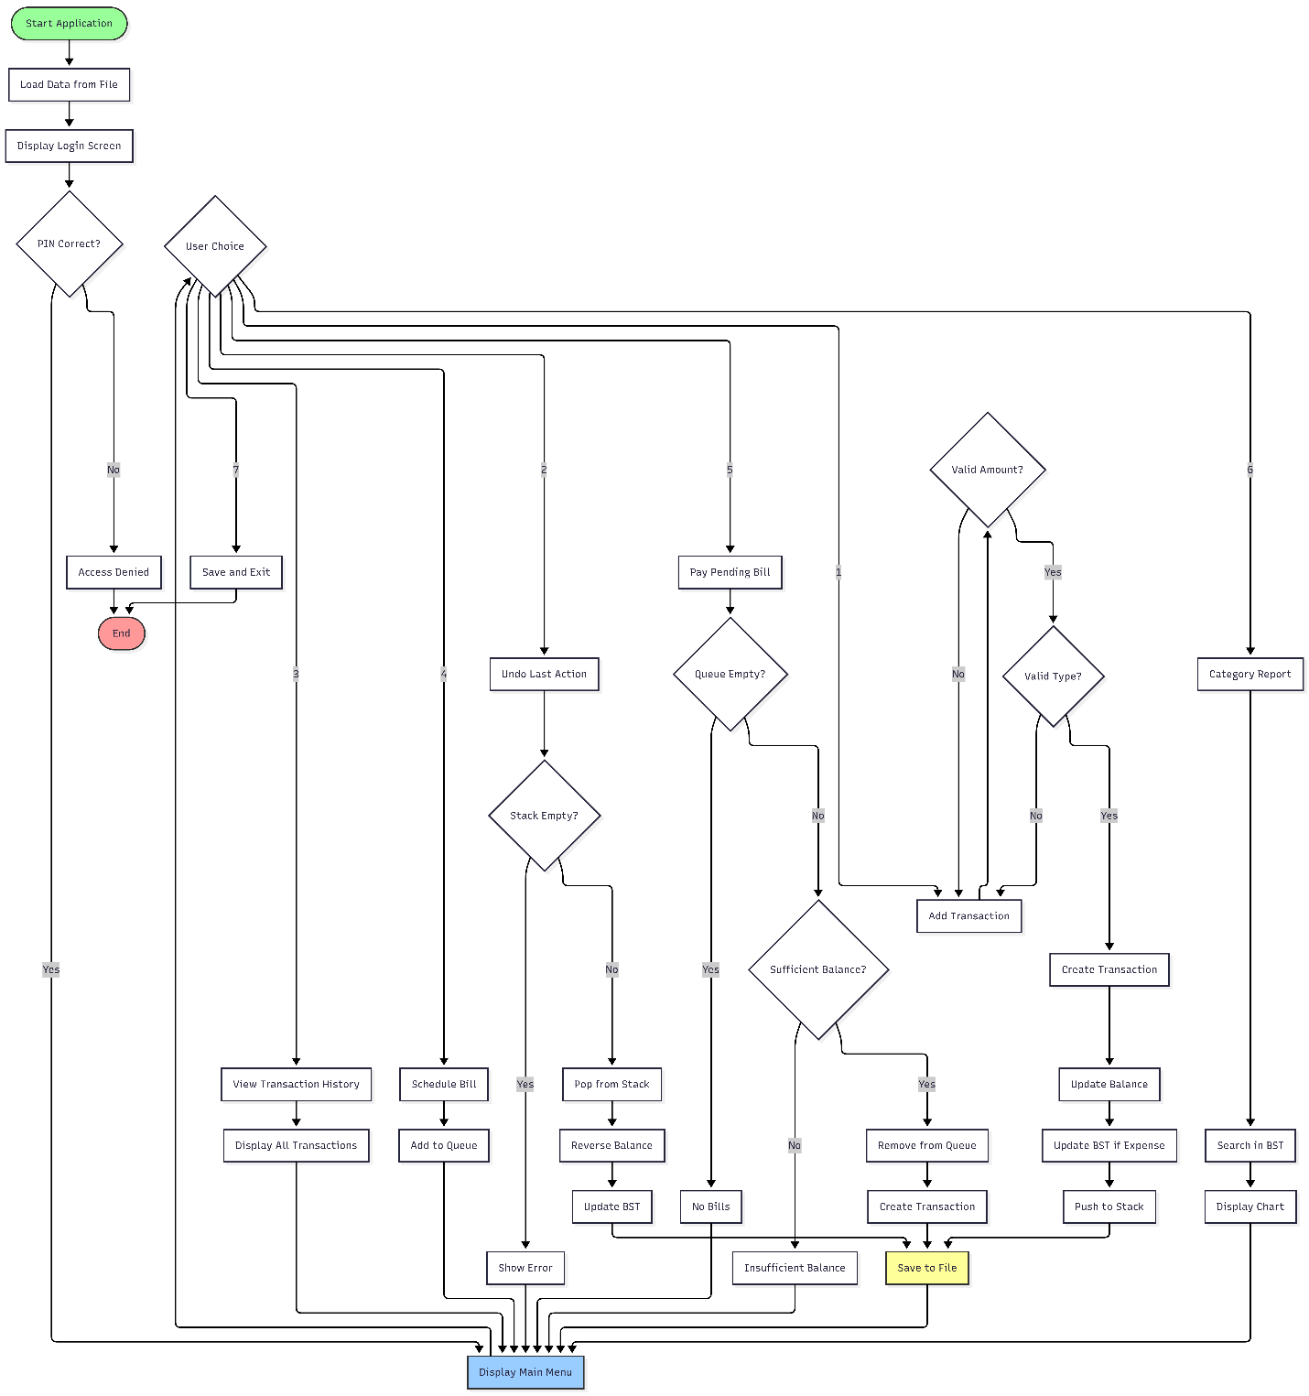

9. IMPLEMENTATION DETAILS

9.1 Key Functions:

9.1.1 Add Transaction:
void addTransaction(double amount, string type, string category)
- Creates new transaction node
- Inserts at front of doubly linked list
- Updates balance
- Pushes to undo stack
- Updates BST for expenses
- Saves to file
Time Complexity: O(log n)

9.1.2 Undo Last Transaction
void undoLast()
- Pops from stack
- Reverses balance change
- Updates BST (subtracts amount)
- Removes from linked list
- Saves updated data
Time Complexity: O(log n)

9.1.3 Category Search
double searchBST(CategoryNode* node, string category)
- Recursive BST search
- Returns total spending
- O(log n) average case

9.2 Memory Management

9.2.1 Destructor Implementation
~PennyStack()
- Deletes all transaction nodes
- Clears stack
- Clears queue
- Deletes entire BST
- Prevents memory leaks

9.3 File Handling

9.3.1 Data Format
[Balance]
[ID] [Amount] [Type] [Category]
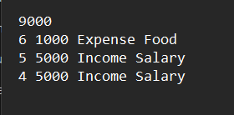
[ID] [Amount] [Type] [Category]

9.3.2 Save Function
- Opens file in write mode
- Writes balance first
- Writes all transactions
- Closes file

9.3.3 Load Function
- Opens file in read mode
- Reads balance
- Reads transactions
- Rebuilds data structures

10. TESTING & RESULTS

10.1 Test Cases
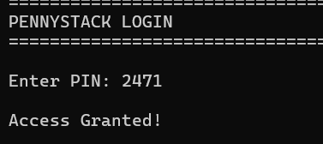
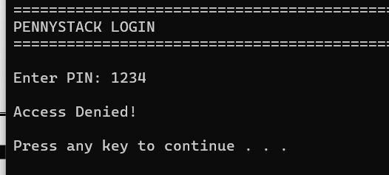
Test Case 1: User Authentication
Test ID | Input | Expected Output | Actual Output | Status
TC-01 | PIN: 2471 | Access Granted | Access Granted | Pass
TC-02 | PIN: 1234 | Access Denied | Access Denied | Pass
Test Case 2: Add Transaction
Test ID | Amount | Type | Category | Expected Balance | Actual Balance | Status
TC-03 | 5000 | Income | Salary | 5000 | 5000 | Pass
TC-04 | 1500 | Expense | Food | 3500 | 3500 | Pass
TC-05 | -100 | Income | Test | Error | Error | Pass
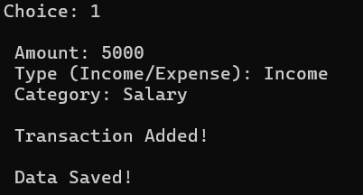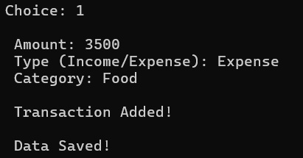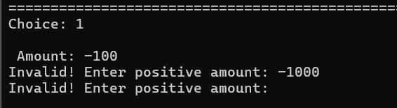
Test Case 3: Undo Functionality
Test ID | Action | Expected Result | Actual Result | Status
TC-06 | Undo last expense | Balance restored | Balance restored | Pass
TC-07 | Undo with empty stack | Error message | Error message | Pass
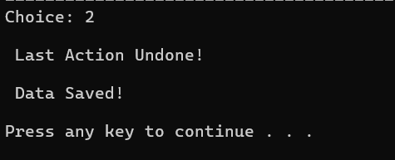
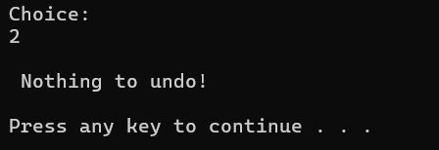
Test Case 4: Bill Management

Test ID | Bill Name | Amount | Balance | Expected Result | Status
TC-08 | Electricity | 2000 | 5000 | Bill Scheduled | Pass
TC-09 | Pay Bill | 2000 | 5000 | Payment Success | Pass
TC-10 | Pay Bill | 10000 | 3000 | Insufficient Balance | Pass
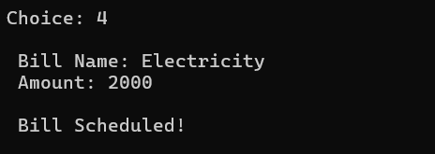
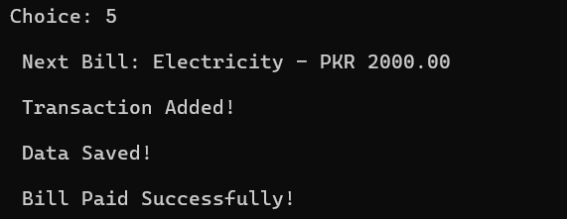
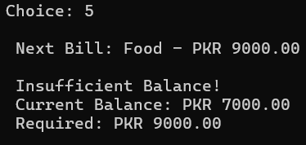
Test Case 5: Category Search
Test ID | Category | Expected Total | Actual Total | Status
TC-11 | Food | 1500 | 1500 | Pass
TC-12 | Transport | 0 | 0 | Pass

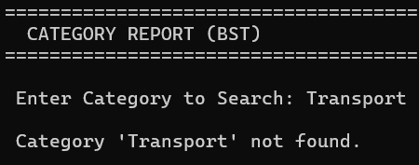
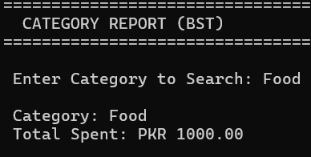

10.2 Performance Analysis
Operation | Time Complexity | Space Complexity
Add Transaction | O(log n) | O(1)
Undo | O(log n) | O(1)
View History | O(n) | O(1)
Schedule Bill | O(1) | O(1)
Pay Bill | O(log n) | O(1)
Category Search | O(log n) | O(1)

10.3 Test Summary
- Total Test Cases: 12
- Passed: 12
- Failed: 0
- Success Rate: 100%

11. SCREENSHOTS

11.1 User Interface Screenshots
Screenshot 1: Login Screen
- Description: PIN-based authentication screen
- Features shown: PIN input, access control

Screenshot 2: Main Menu
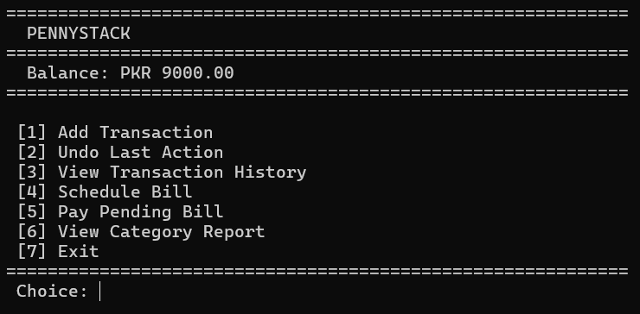
- Description: Main application menu
- Features shown: All 7 menu options, current balance display

Screenshot 3: Add Transaction
- Description: Adding a new income transaction
- Features shown: Amount input, type selection, category input

Screenshot 4: Transaction Added Confirmation
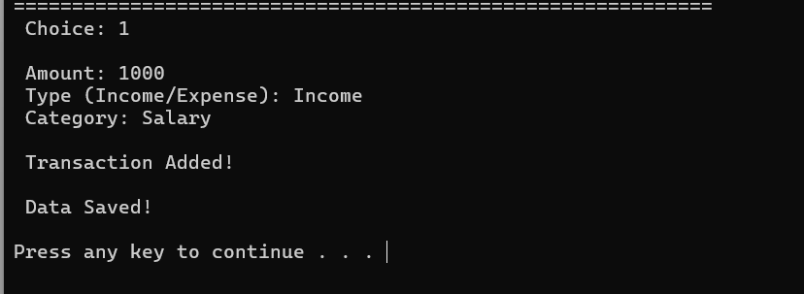
- Description: Success message after adding transaction
- Features shown: Confirmation message, updated balance
Screenshot 5: Transaction History
- Description: Complete transaction history view
- Features shown: ID, Type, Category, Amount columns, total count

Screenshot 6: Undo Operation
- Description: Undoing last transaction
- Features shown: Undo confirmation, balance restoration

Screenshot 7: Schedule Bill
- Description: Scheduling a new bill
- Features shown: Bill name input, amount input

Screenshot 8: Pay Pending Bill
- Description: Paying next bill in queue
- Features shown

12. CONCLUSION

12.1 Project Summary
PennyStack successfully demonstrates the practical application of fundamental data structures in solving real-world financial management problems. The system implements five core data structures—Doubly Linked Lists, Stacks, Queues, Binary Search Trees, and Hashing—each serving a specific purpose in creating an efficient expense tracking application.
Key Achievements:
- Transaction Tracking: Doubly linked lists for efficient storage and retrieval
- Error Correction: Stack-based undo functionality
- Bill Management: Queue for organized bill scheduling
- Category Analysis: BST for fast category searching
- Security: Hash-based PIN authentication

12.2 Objectives Achievement
Primary Objectives - ACHIEVED
- Functional System: Successfully handles income/expense transactions with accurate balance tracking
- Data Structures: All five structures (Linked List, Stack, Queue, BST, Hash) implemented effectively
- Security: Hash-based authentication protects user data
- Performance: Efficient operations (O(1) to O(log n))
- Persistence: File-based storage with automatic save/load
Secondary Objectives - ACHIEVED
- User Interface: Intuitive menu with clear navigation
- Validation: Comprehensive input and error handling
- Visualization: ASCII charts for spending analysis
- History: Complete transaction tracking and display
- Bill System: Queue-based scheduling with balance verification

12.3 Learning Outcomes
Technical Skills:
- Mastery of data structure implementation
- Dynamic memory management in C++
- File I/O and data persistence
- Object-oriented programming principles
- Algorithm optimization
Problem-Solving:
- Selecting appropriate data structures for specific tasks
- Handling edge cases and error scenarios
- Debugging complex pointer operations
- Balancing time vs space complexity

Professional Development:
- Complete project lifecycle experience
- Code documentation and testing
- Report writing and presentation
- Real-world application development

12.4 Project Impact
Educational Value:
- Bridges theory and practice
- Demonstrates real-world data structure applications
- Builds programming confidence
- Creates portfolio-worthy project
Practical Utility:
- Helps users manage personal finances
- Provides spending insights
- Enables better financial decisions
- Offers easy expense tracking

12.5 System Strengths
- Efficiency: Fast operations with optimal data structures
- Usability: Simple, intuitive interface
- Reliability: Robust error handling and validation
- Security: Protected user authentication
- Flexibility: Easy to extend and enhance
- Maintainability: Clean, well-documented code

12.6 Limitations
- Single User: No multi-user support currently
- Console-Based: Limited to text interface
- Local Storage: No cloud backup or sync
- Basic Reports: Limited analytical capabilities
- No Date Tracking: Transactions lack timestamps

12.7 Final Remarks
PennyStack successfully achieves its goal of creating a practical, efficient expense tracking system while demonstrating the power of data structures in real-world applications. The project provided valuable hands-on experience in software development, from design to implementation to testing.
The system is fully functional, well-tested, and ready for use. With the proposed future enhancements, PennyStack has the potential to evolve into a comprehensive financial management platform.
Key Takeaway: Choosing the right data structure is crucial for building efficient, scalable applications. This project proves that theoretical computer science concepts have direct, practical applications in solving everyday problems.

